Where

Physical Education News………..St. Mary’s 2018-19

Mrs. Samantha Nienberg

Hello to the beginning of another great school year at St. Mary’s. I am so happy to be back working with the students in the gym during P.E. class.

In P.E., we began the school year with cooperative games for all grades. Students in grades K-4 then moved on to traveling movements while grades 5-8 learned how to use a compass during our orienteering unit. We sure are having some fun in the gym to start out the year.

I plan to continue to use self responsibly and self accountability in class with cooperative activities, the Conflict Corner, and self assessment.

Please remember P.E. classes take place on Mondays and Tuesdays so make sure your child is wearing the proper shoes and clothes for class that day. Thank you again for having me here at St. Mary’s. I am having a BLAST!!!!

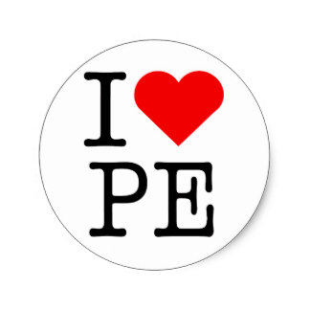

UPCOMING EVENTS

We will have jump rope for heart to raise money for the American Heart Association in Feburary 2019.



**!!!!!REMINDER!!!!!!**

**Monday & Tuesday are Gym days. Please wear the proper shoes.**

C:\Users\samantha\AppData\Local\Microsoft\Windows\INetCache\IE\748KO8VZ\bi[1].gifC:\Users\samantha\AppData\Local\Microsoft\Windows\INetCache\IE\748KO8VZ\bi[1].gifC:\Users\samantha\AppData\Local\Microsoft\Windows\INetCache\IE\748KO8VZ\bi[1].gif

Gym

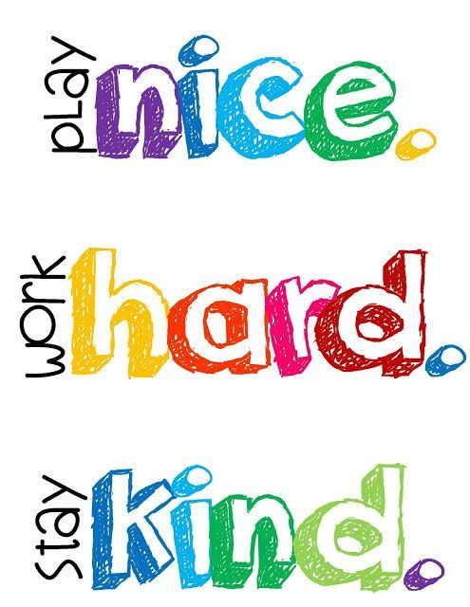



If you ever have any question or concerns about your child, please feel free email me at: [snienberg@ls.noacsc.org](mailto:snienberg@ls.noacsc.org)

Mrs. Samantha Nienberg