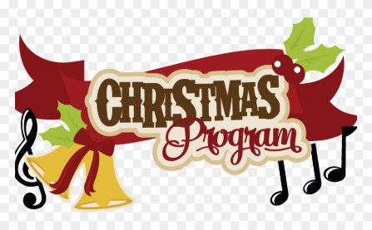
St. Mary’s Catholic School
Grades Pre Kindergarten – 8th Grade
Christmas Program
December 9th, 2018
3pm at the Parish Life Center

