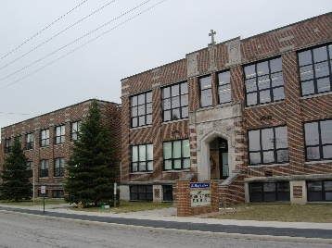
St. Mary School
129 Saint Mary Street Phone 419.943.2801
Leipsic, Ohio 45856 Fax 419.943.3555
Website: ls.noacsc.org
Offering Work Love & Sacrifice

As a significant ministry of St. Mary’s Parish, our mission is to
support the faith formation of families, providing a quality education within a Catholic Christian setting. Our purpose is to nurture
the life of Jesus within each child through programs and experiences that allow them to mature into disciples of Christ.

Week of October 15th, 2018

GREAT HAPPENINGS
October 21st – 26th – Red Ribbon Week
October 22nd – October 26th – 3rd Grade YMCA Swim
October 26th - 5th, 6th, 7th, 8th – Sauder’s
November 1st – All Saints Party and Pizza Day
November 1st – Personal Safety – 1st, 3rd, and 5th
November 2nd – Halloween / All Saint’s Costume Parade
November 9th – Picture Retake
November 11th – Harvest Breakfast
November 21st – 25th – No School Happy Thanksgiving
November 24th – 25th – Wreath Distribution
November 29th – Culture Project 4:00 – 8:30
November 30th - Pizza Day
December 5th – Walleye Game (Pizzeria Fundraiser Reward) Details to Follow
December 9th – Christmas Program (Details to Follow)
December 12th – Culture Project 4:00 – 8:30
December 24th – January 2nd – No School Christmas Break
All Saint’s Day
November 1st – All Saint’s Day Party and Costume Contest during the school day. Details to follow.
November 2nd – 2pm we will have our costume parade. Please feel free to dress up in a Halloween Costume or All Saint’s Costume.

Word from the Principal
Wow, what an amazing week and half we have had here at St. Mary’s. Thank you to the Grandparent’s and Bishop Daniel Thomas for visiting the school. This week was fire prevention week. The Pre-Kindergarten and Kindergarten students were able to visit the fire station and grades 1st through 4th grade was able to visit the smoke house. Our confirmation candidates listened to the Culture project. There will be no school on Thursday and Friday of this week. Please enjoy the time with your family. Have you had a chance to check out the new website? ls.noacsc.org If not, please take a moment to check it out. Also, please check your emails, the weekly newsletters will begin to be sent electronically. Beginning the week of November 5th, the only way to receive the newsletter and inserts will be via email or website. The homeschool folders will be sent home only in times when information, such as, tuition invoices cannot be emailed. Do you know a grandparent, aunt, uncle that wants to stay up to date please; have them send an email to mknippen@ls.noacsc.org, I will add them to the list. October is the month of Mary. The students are busy practicing the MEMORARE. Continued blessings to you and your family.
God Bless,
Michelle Knippen

OcTABer
Save your Pop Tabs. In the month of October we will be collecting pop tabs for the Ronald McDonald. As a school we will be having a competition between classes. The class with the most weight of pop tabs at the end of the month will win a pizza party!! Also, we will be competing in the OSU vs. Michigan pop tab competition. All pop tabs will be sent to Columbus.

TUITION PAYMENTS:
Invoices were sent home. Please make payments each month. If you would like a tuition payment booklet you may pick one up at the school office. When making payments, be sure to include the child’s name, amount enclosed and please place in an envelope. Please call the School Office if you have any questions.

Harvest Breakfast ~ NOVEMBER 11th
In Need of – Raffles ITEMS!! Please consider donating an item for the Harvest Breakfast. Items can be dropped off at school. Thanks.
In Need of 5 hogs for Harvest breakfast. If you are able to donate a hog please contact Lauren Schroeder. 419-306-9508

Wreath Fundraiser
Orders Due – October 22nd
This year there are two choices. Check it out!!

Red Ribbon Week
October 22 - 26

Monday - Take a wacky stand against drugs; Crazy Day (crazy socks, hair, etc)

Tuesday- Be as snug as a bug, don't do drugs; Wear pajamas

Wednesday- Wear it with confidence, be drug free; Dress up

Thursday-Support a team, not drugs; wear a jersey

Friday- “Stop” drugs; Wear red; hugs no drugs 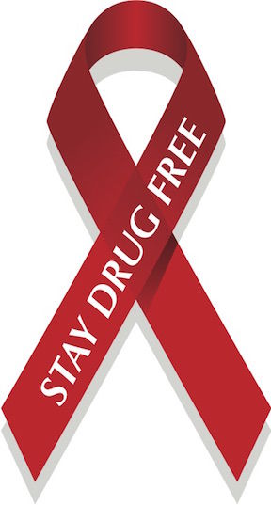

Inserts
- Strong Catholic Families
- Harvest Breakfast Donation
- 8th Grade FFA Convention Checklist

